Indonesia Calls for ASEAN - UK Cooperation on Energy Transition

Jakarta, 13 July 2023 - Indonesia has called for strengthening ASEAN - UK cooperation in the energy transition sector. This was conveyed by the Indonesian Minister of Foreign Affairs Retno at the ASEAN Post Ministerial Conference (PMC) with the UK in Jakarta, Thursday (13/7).
The Foreign Minister said that two years ago the UK became ASEAN's newest Dialogue Partner. This demonstrates ASEAN's commitment to partnership with all countries. These partners are required to share the same values ​​as ASEAN and contribute to peace, stability and prosperity in the region.
At the meeting, the Foreign Minister emphasised two points:
First, maintaining regional peace and stability. Peace in the Indo-Pacific region has lasted more than half a century due to an inclusive regional architecture, with ASEAN at its centre.
“The Architecture of the Region is built on a paradigm of collaboration and compliance with international laws and principles, including the Treaty of Amity and Cooperation (TAC) and Bali Principles. I am sure the UK also adheres to these principles," said the Foreign Minister.
ASEAN also encourages Britain to contribute to ensuring Southeast Asia is a nuclear-free region by quickly acceding to the Treaty of Southeast Asia Nuclear Weapons-Free Zone (SEANWFZ).
Second, encouraging cooperation in the field of energy transition. The ASEAN-UK partnership must contribute to realising net-zero emission in the next 3-4 decades.
For this reason, ASEAN and the UK already have cooperation schemes that can be utilised, such as the ASEAN-UK Catalytic Green Finance Facility Trust Fund. This cooperation will strengthen the ASEAN-UK partnership as a “partnership of the future.”
During the meeting, the topic of strengthening ASEAN-UK economic cooperation was discussed, including increasing trade, investment, supply chain resilience, digital trade, innovation and cyber security. Several ASEAN countries proposed the possible establishment of an ASEAN-UK Free Trade Agreement.
In the field of politics and security, the meeting highlighted the importance of British support for the formation of a regional architecture based on the paradigm of collaboration and adherence to international law. Specifically, ASEAN encourages the UK to immediately accede to the SEANWFZ Treaty Protocol.
In addition, the meeting also agreed to increase cooperation in the areas of climate transition, clean energy, strengthening health infrastructures, and natural disaster mitigation. The UK will also advocate for cooperation in empowering women and girls, including in the context of Women, Peace and Security (WPS) and access to education.
***

For further information, please contact the following:

Director for Information and Media of the Ministry of Foreign Affairs - Hartyo Harkomoyo (+62811831899)

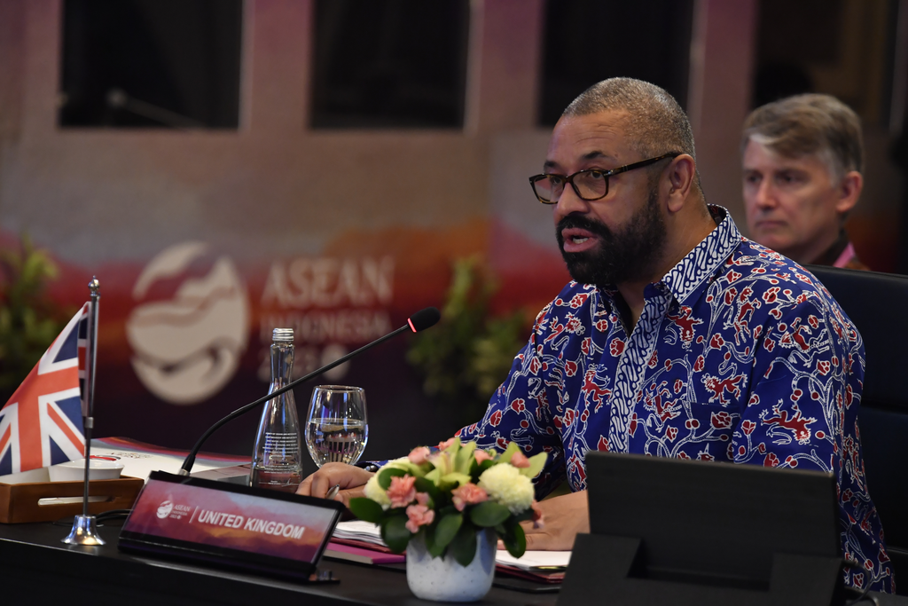

Indonesia has called for strengthening ASEAN - UK cooperation in the energy transition sector at the ASEAN Post Ministerial Conference (PMC) with the UK in Jakarta (13/7) (Photo: Ministry of Foreign Affairs of Indonesia).

